The calculate function performs basic arithmetic operations (addition, subtraction, multiplication, and division) on two input numbers and prints the results to the console.

**Function Breakdown:**

1. **Parameters**:
   * num1: The first number.
   * num2: The second number.
2. **Operations**:
   * The function calculates the following operations using the input numbers:
     + **Addition**: num1 + num2
     + **Subtraction**: num1 - num2
     + **Multiplication**: num1 * num2
     + **Division**: num1 / num2
3. Each result is logged to the console in the format:  
   "Operation: Result".

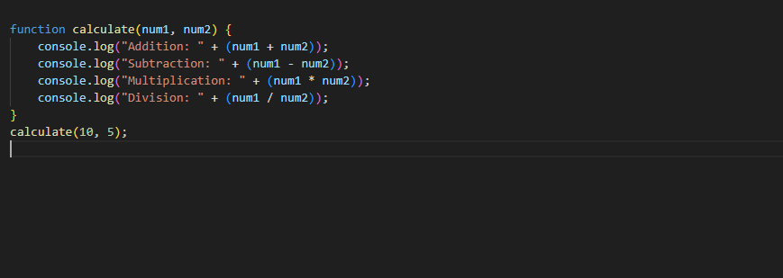

Output:

